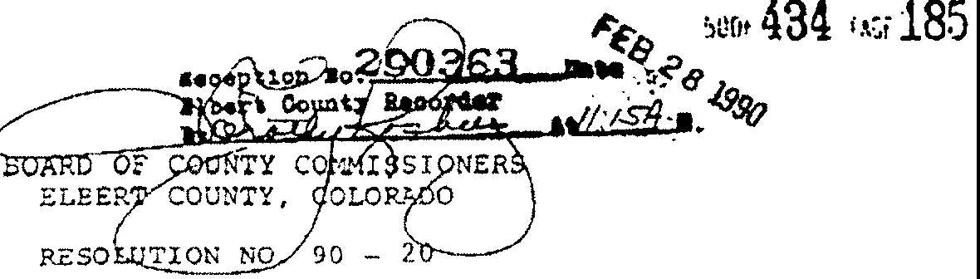
PROVIDING FOR THE PP.OHIBITrON OF THE DISCHA."{G£ OF FIREARMS
WITHIN DESIGNAT.ex> UNINCORPORATED ARUS

WHEREAS, the Board of County Commissioners is ernpo ered to prohibit the ischarge of firea:rms within the unincorporated areas of Elbert County, Colorado, pursuant to Colorado Revised Sta utes, 30-15-301 ec see., s ar.1e ded; anc
"I • -
WHEREAS, the Board of County Commissioners of Elbert county, Colorado, has found and determined that in subdivisions located within the unincorporated areas of Elbert County, Colorado, which contain therein lots with an area of ten or less acres, there is a real and present danger to the health, safety, and welfare of the public, including a substantial dAnger to their property, caused by the discharge of firearms which requires in Elbert· County, Colorado, that a resolution be adopted pursuant to the power granted to the Board of County Commissioners by the afore­ se.id statute.
NOW, THEREFORE, BE IT RESOLVED BY THE BOARD OF COUNTY COMMIS­ SIONERS OF ELBERT COUNTY, COLORADO, AS FOLLOWS:
l. That this Resolution is enacted for the health, safety, and we..J.fare of the residents of Elbert County, Colorado, and pursuant to coiorado Revised Statutes, 30-15-301 et seq., as amended.
- •Firearm" or "firearms• shall mean any pistol, revolver, rifle, or ottier weapon of any description from which any shot, projectile, or bullet may be discharged.
- "Su division" shall mean any subdivision within the un­ incorporated areas of Elbert County, Colorado, which cor.tain therein lots with an area of ten or less acres - which have
a population density of not less than one hundred pe:$or.s per square mile.
- It shall be ur.lawful for any person to discharge any firearm, exce?t in a situation involving a duly authorized law enforcement officer acting in the line of duty, within any sub­ division as the.t term is defined herein.
- Notting in this :Resolution she.11 prevent the dischax'ge of ny firearm in shooting galleries whic comply with the
Elbert County zoning Regulations and the Elbert County subdivision

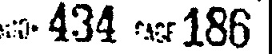

P.egulations or on any private grouncs or residence under circwn­ stances when such firearm can be discharged in sueh a manner as not to endanger persons or property and also in such a manner as to prevent the projectile from any such firearm from traversing any grounds or space outside the limits of sucn shooting gallery, grounds, or residence.
- Nothing in this Resolution shall be construed to restrict or otherwise affect any per.son's constitutional right to bear arms or his right to the cefense of his person, his family, or his property. •
- Any person violating anr p:ovision5 of this Resolution is guilty of a misdemeanor and, U?On conviction thereof, shall be punished by a fine of r.ot more than one hundred dollars.
- All fines and forfeitures for the violation of this Resolution shall be paid into the Treasury of_ Elbert County, Colorado.
- The Board of county Commissioners of Elbert County, Colorado, by the District Attorney for the Eighteenth Judicial District, shall prosecute any violations occurring hereunder.
- The County Court for the County of Elbert, State of Colorado, shall have jurisdiction in prosecutio_ns of violations of this Resolution.
- Notice of this Resolution and adoption hereof shall be published in a newspaper of general circulation within the County of Elbert, State of Colorado, for two (2) consecutive weeks fol­ lowing the date of adoption.of this Resolution. The notice shall provide that this-Resolution shall remain in full force
and effect from the date of its adoption until rescinded or .
·amended by fpture resolution and order of the Board of county Commissioners.
- In the event any provision of this Resolution, or the application thereof to any person or circumstance, is held to be invalid, such invalieity shall not affect the other provi­ sions or sections of this Resolution or the application of same, and, to this end, the nrovisions of this Resolution are declared to be severable. •
- This Resolution shall become effective on the .day
of February , 1990.

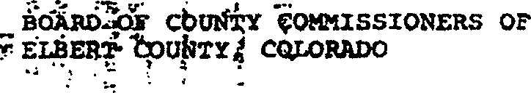

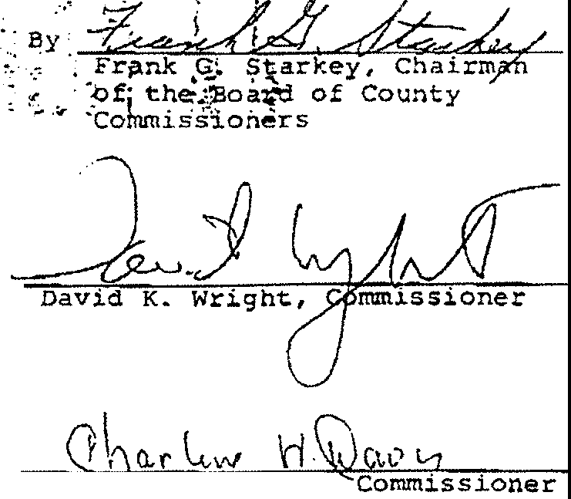

Carine H. Davis,

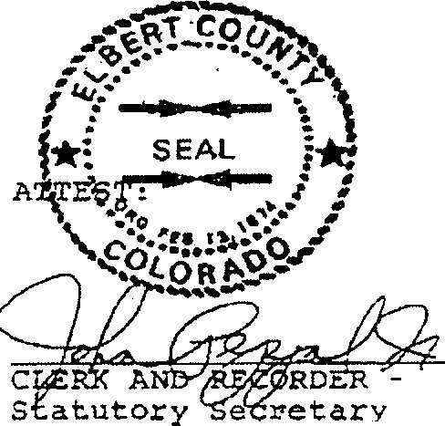
Board of county Com. issioners
to the

- 3 -

